Make it Personal
Pick your meat
Black Forest or Tavern Ham 6.49
Salami 6.49
Oven Roasted or Smoked Turkey 7.49
Roast Beef 7.49
Lebanon Bologna 7.49

Pick your Cheese
Basic 50¢
American, Provolone, Pepper Jack, Cheddar, Colby Jack
Gourmet 75¢
Muenster, Swiss, Horseradish

Pick your bread
White, Whole Wheat, Kaiser Bun Inc.
Marbled Rye, Hoagie Buns, Wraps 1

Pick your toppings
Lettuce, Tomato, Onions Inc. Slaw, Kraut, Hummus 1
Extra Meat 2

Side Options
Add for just $1
German Potato Salad
Amish Macaroni Salad
Cole Slaw
Pepper Slaw
Broccoli Salad
Giant Pickles
Wee Bags of Chips

Ask about today’s Soups
Soup 3.99
Add soup to any sandwich 1.99

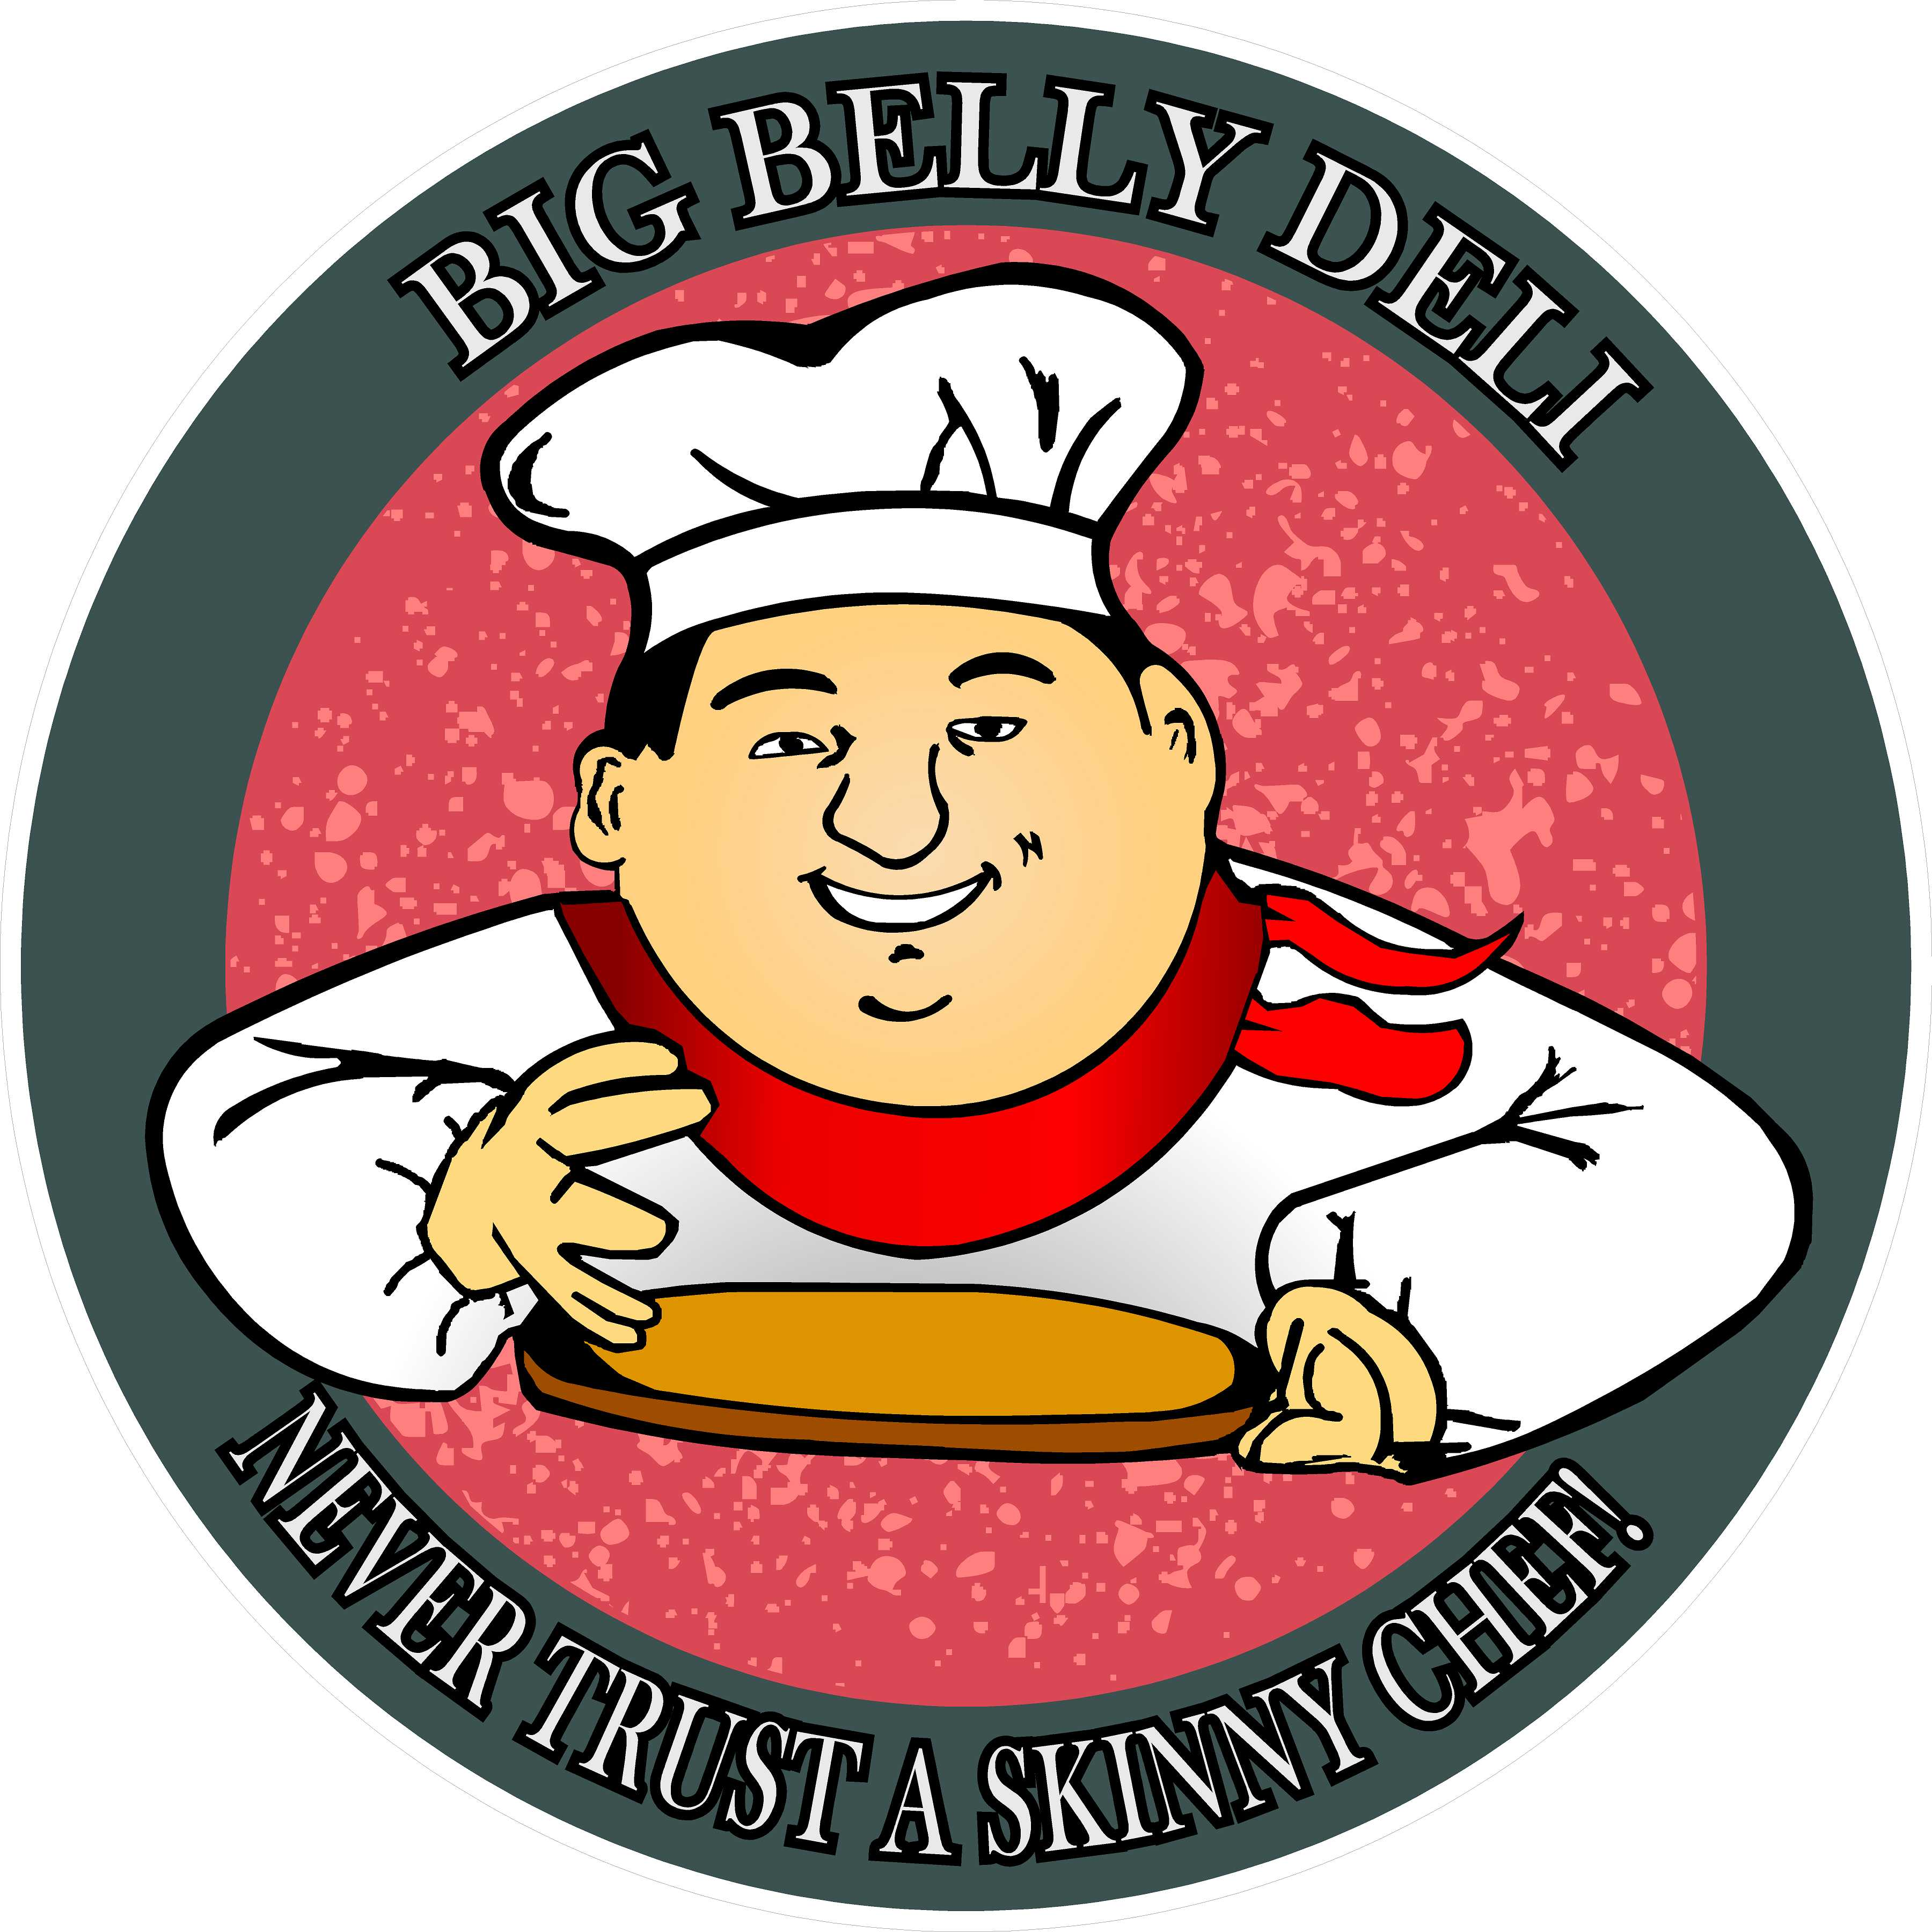

Big Belly Deli
438 William Ave
Davis, WV 26260

Founded in 2013 and located in historic Davis, WV. Big Belly Deli was started with the idea that food should be not only quick, but fun, filling, and inexpensive. We searched the globe (or at least our little corner of it) to bring you the best ingredients that we could find for our made-to-order sandwiches, deli salads, soups, and baked goods to meats & cheeses by the pound. We wanted to make sure that you never went hungry.

Oh, who are we kidding? We just wanted to be able to get a Pastrami sandwich in this town.

We offer only the finest ingredients available locally, seasonally, regionally & from around the world.

Hours
Friday - Tuesday 11am-4pm
Closed Wednesday & Thursday

Phone: (304)259-2222
Find us on Facebook at:
Davis’s Big Belly Deli

Big Belly Deli

Never Trust a Skinny Chef

Freshly made Soups, Deli Salads, Sandwiches and More.

Phone: (304)259-2222

Spring 2020

Menu

Non-Meats
For those who are vegetarians, vegans or just playing healthy. Served with a pickle spear & one of our famous Cowboy Cookies
Burger | 7.99
House made Black Bean burgers served with your choice of cheese, lettuce, tomato & onion on a grilled bun.
Add bacon $2
Veggie Rueben | 8.99
Sautéed mushrooms & onions topped with swiss cheese, sauerkraut & 1000 island dressing served on grilled rye bread.
Hummus Wrap | 6.99
Homemade garlic hummus served with our southern-style pepper slaw & your choice of cheese.
Add turkey $2
Egg Sandwich | 4.99
Fried egg with your choice of cheese & bread, lettuce, tomato & onion

For the Wee Ones
Served on Mom and Dad’s choice of bread with a pickle spear & one of our famous Cowboy Cookies
PB&J | 4.99
Creamy or Crunchy, Strawberry or Grape.
Classic Grilled Cheese | 4.99
Just like Mama makes, all we need to know is squares or triangles. (come on it’s important)

Classics
The classic sandwiches we all grew up with. Served on your choice of bread with a Pickle Spear & one of our famous Cowboy Cookies.
Pepperoni Roll | 4.99
A WV staple made with homemade bread filled with pepperoni & mozzarella served hot with sauce upon request.
Add sautéed Peppers & Onions for $1
Chicken Salad 7.99 |  | 5.99
Made fresh from house-grilled  chicken breast served with lettuce tomato & onion  Breakfast BLT | 7.99
Classic bacon, lettuce and tomato topped with an egg. No egg, no problem.
Hot Pastrami | 8.99
As God intended, swiss cheese, grilled onions & stone ground mustard on grilled rye bread
Rachel | 8.99
Your choice of turkeys served warm with muenster & cole slaw on grilled rye.
Rueben | 8.99
Your choice of Corn Beef, Turkey, Pastrami, or Lebanon Bologna topped with swiss cheese, sauerkraut & 1000 island dressing served on grilled rye.
Cold Cuts | 9.99
Italian: Capicola, pepperoni, salami, with provolone
American: Ham, turkey, roast beef with Colby jack
With lettuce, tomato, onion on a hoagie bun

Fan Fav’s
Our regulars gave us some good ideas served with a pickle spear & one of our famous Cowboy Cookies.
Italian Sausage | 7.99
House ground Italian sausage served with grilled onions & peppers on a toasted bun.
The Messy Becky | 8.99
Roast beef topped with horseradish cheese, sautéed mushrooms & onions served on a toasted bun.
The Dead Parrot | 8.99
Pastrami, warmed, topped with horseradish cheese & our house pepper slaw on your choice of bread.
The Girl’s Dream | 8.99
Your choice of turkey served warm with swiss cheese, grilled onions & our house chipotle aioli on your choice of bread.
The Chipwich | 8.99
Our house Italian sausage patty topped with sautéed peppers & onions, a fried egg served on a toasted bun.
Red’s Barnyard 9.99
Roast beef, bacon, & a fried egg, topped with pepper jack cheese, lettuce, tomato, & onion served on a toasted bun.

